**Implementation Checklist:**

|  |  |
| --- | --- |
| **Client Name:** |  |

**Main Contact Person:**

|  |  |  |  |
| --- | --- | --- | --- |
| **Name & Surname** | **Position** | **Email Address** | **Contact Number** |
|  |  |  |  |
|  |  |  |  |
|  |  |  |  |

**Information received Checklist:**

|  |  |  |  |
| --- | --- | --- | --- |
| **Checklist** | **Yes** | **No** | **Notes/Questions:** |
| Existing Planning Process: |  |  |  |
| Planning Methodology: |  |  |  |
| Planning Cycle: |  |  |  |
| Accounting System: |  |  |  |
| Operations: |  |  |  |
|  |  |  |  |

**Integration Checklist:**

|  |  |  |
| --- | --- | --- |
| **Mark (X)** | **Service required** | **Fields provided** |
|  | AVT |  |
|  | Routes |  |
|  | Planning |  |
|  | Insight |  |
|  | Mobility |  |
|  | On-Route Execution |  |
|  | Vortex |  |
|  | Gatekeeper |  |
|  | Fuel Bowser |  |

**Connection List:**

|  |  |
| --- | --- |
| Connection List: (Only one to be used) | **Mark(X)** |
| Web Service |  |
| Polling Listener |  |
| SFTP / FTP |  |
| Email Listener |  |
| Flat File Listener |  |

**Sample Documentation received:**

|  |  |  |  |
| --- | --- | --- | --- |
| Sample Documentation: | **Yes** | **No** | **N/A** |
| Waybill |  |  |  |
| Invoice |  |  |  |
| Delivery Note |  |  |  |
| Trip Sheet - Selection |  |  |  |
| Other driver documents (Please Specify) |  |  |  |

**Curo – Setting: Set-up Routes:**

|  |  |  |  |  |
| --- | --- | --- | --- | --- |
| **General:** Server Connection Alarm | | Yes | No | N/A |
| **Display:** | Vehicle Display on system | By Registration | |  |
|  |  | By Call Sign | |  |
|  |  | By Driver | |  |
|  | Display Vehicle Labels on map | Yes | | No |
|  | Follow Vehicles on map | Yes | | No |
|  | Display DECO Labels on map | Yes | | No |
| **Tracking:** | Vehicle Connectivity Threshold (hh:mm:ss) |  | |  |
| **Routing:** | Close Routes | Automatically | |  |
|  |  | Manually | |  |
|  | Manage route by | Shortest | |  |
|  |  | Fastest | |  |
|  | Action Suggestions | On | |  |
|  |  | Off | |  |
|  | Action Management Type | DECO | |  |
|  |  | Entity | |  |
|  | Unplanned Stop Threshold (hh:mm:ss) |  | |  |
|  | Unattended Stop Threshold (hh:mm:ss) |  | |  |
| **CTC:** | CTC Reference | Generated | |  |
|  |  | Manual | |  |

**Curo – Routing Template Set-up:**

|  |  |  |  |  |  |
| --- | --- | --- | --- | --- | --- |
| **Name:** |  | |  | |  |
|  | Routing Options: | | Fastest | |  |
|  |  | | Shortest | |  |
|  | Planned Start Date | | Today | |  |
|  |  | | Tomorrow | |  |
|  | Planned Start Time: (hh:mm:ss) | |  | |  |
| **General:** | | Maximum Stop Time | | ______ Minutes | |
|  | | Maximum Speed: | | ________ Km/h | |
|  | | Route Deviation Threshold (%) | | _______ % | |
|  | | Instructions: | |  | |
| **Activation:** Strategy: | | Start on departure | |  | |
|  | | Start on Arrival | |  | |
|  | | Manual | |  | |
| Selection: | | Apply Threshold | |  | |
|  | | Automatically Adjust Planned Start | |  | |
| **Termination:** Strategy | | Terminate on departure | |  | |
|  | | Terminate on Arrival | |  | |
|  | | Manual | |  | |
| Selection: | | Tolerance | |  | |
|  | | Only if all DECO’s visited | |  | |
| **Personnel:** | | **Auto Assign Personnel:** - Personnel will be assigned on driver tags or the driver currently assigned to the vehicle. | | YES / NO | |
|  | | Manage Personnel Assigned to the route: | | YES / NO | |
|  | | List of Personnel – who to assign to the route | |  | |
| **Routing Options:** | | Fastest | | Shortest | |
| Select: | | Route closest stop first? | |  | |
|  | | Excluded Dirt Roads? | |  | |

**Checklist:**

|  |  |  |  |
| --- | --- | --- | --- |
|  | **Yes** | **No** | **Notes:** |
| Personnel information received |  |  |  |
| Logo received for any reporting |  |  |  |
| Settings for client personnel loaded – Notification Personnel |  |  |  |
| Bulk upload for personnel sent & request for pins |  |  |  |
| File received back with pins |  |  |  |
| Information to maintain sequence from planning to Trackmatic to optimize |  |  |  |

### Specific fields required for integration:

The fields below per section, if provided, can be created within trackmatic. An example for each section has been provided for clarity. Please note that not all fields are mandatory unless specified in the second column.

Checklist:

|  |  |  |  |
| --- | --- | --- | --- |
|  | **Yes** | **No** | **Notes:** |
| DECO’s |  |  |  |
| Routes |  |  |  |
| Entity |  |  |  |
| Action |  |  |  |

**Entity:**

#### 

#### 

**Deco:**

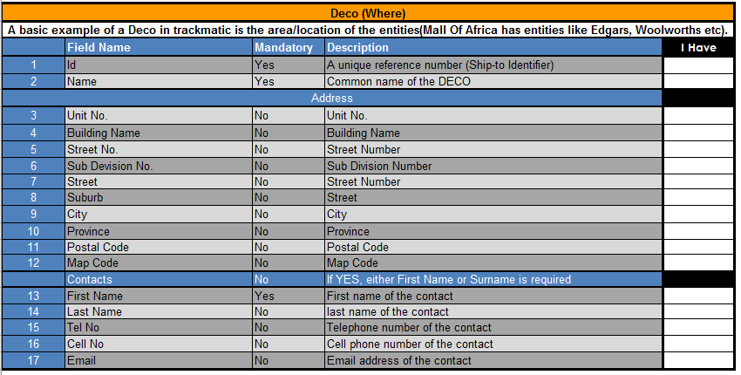

**Route:**

NB: An entity, deco and action should be specified for each route.



#### 

**Handling Unit:**

NB: This is optional functionality and can be of use if the line of business supports it.